Improving the use of arid areas
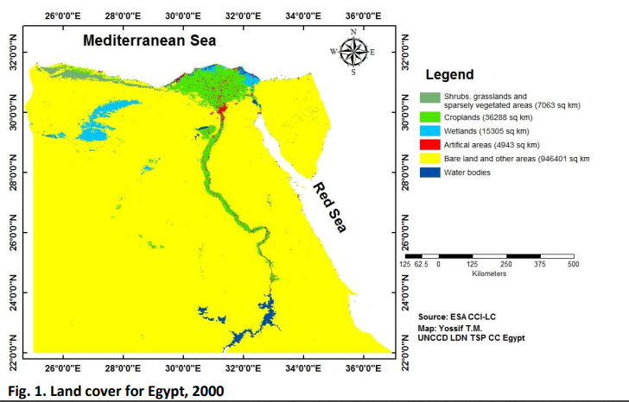
Egypt is a large country that covers an area of 1,002 million square kilometers, The country has a strategic geographic location that connects Asia and Africa and connects the Mediterranean and red seas through the Suez Canal. However, despite the large size of Egypt, it suffers from many problems like urban congestion and insufficient agricultural production. This is because 96% of Egypt’s land is barren, as shown in Figure 1.
Egypt’s desert lands can be split into 3 main areas, The western desert, The eastern desert, and The Sinai Peninsula. Despite low or non-existent agricultural production, these areas produce crude oil and/or natural gas.
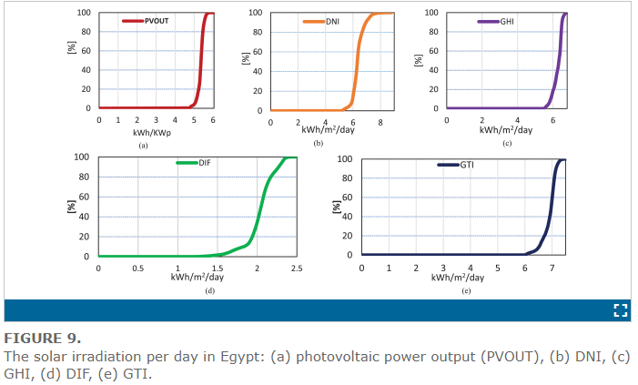
The western desert has 56% of Egypt’s crude oil production and natural gas equals 18% of Egypt’s natural gas production. The eastern desert produces 12% of Egypt’s crude oil. The Sinai Peninsula produces 9% of Egypt’s crude oil. However, all these areas have a very low, barely existent agricultural production, The oases in the region do not make a tangible difference in the overall agricultural production. Therefore, the development of these arid areas for agricultural production is needed. Furthermore, Egypt's geographic location makes it a perfect candidate for solar energy production as the highest direct normal irradiation (DNI) it receives is 3069 kWh/m²/y in south Sinai and the lowest is 1890 kWh/m²/y in Alexandria. The global solar atlas of Egypt is shown in Figure 2.
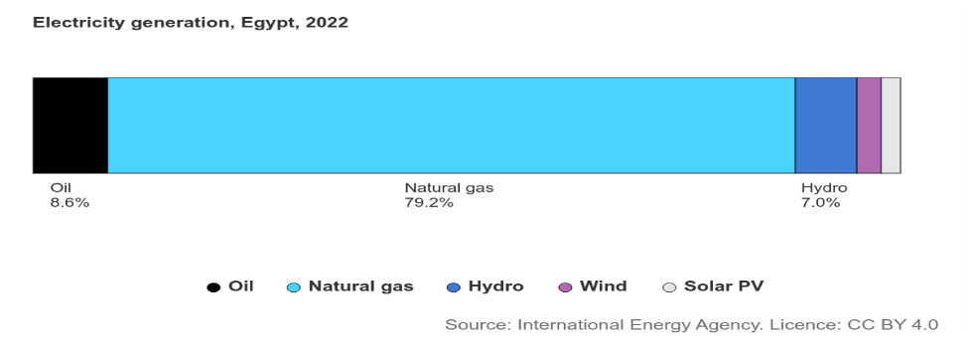
Despite the perfect locations for generating solar power like the Sinai Peninsula, Western Desert and Eastern Desert, solar energy consumption only made up 2.4% of Egypt’s total energy consumption in 2022, which is shown in Figure 3. Which is due to Egypt not utilizing its vast arid areas properly.
1 Figure 3
2 figure 2
Source 1:https://ieeexplore.ieee.org/document/9668970?denied=
Causes
1. Geographic Location
Due to Egypt’s location in north Africa, 96% of the country’s surface area is covered by the western and eastern deserts, both of which are part of the Sahara desert, One of the hottest and driest of the world’s deserts with temperatures reaching up to 57.7 Celsius with extremely rare rain falls as inland Sahara only receives 1.5 cm of rainfall per year, greatly limiting the habitability of the western and eastern deserts in non-coastal areas and making construction of large mines in most of the two deserts extremely difficult if not impossible, and not economically efficient.
2. Land Composition
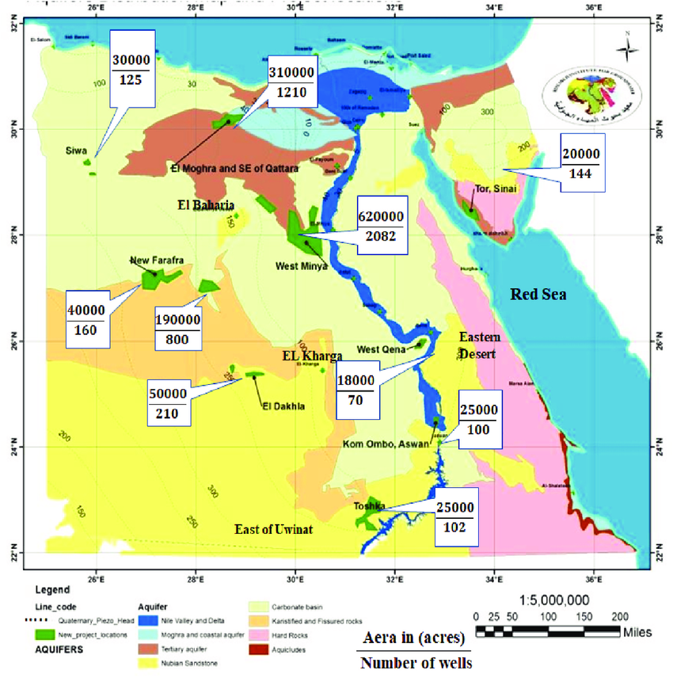
Due to the land composition in the Western and Eastern deserts agricultural production outside of the few scattered oases in them is complicated as the Western desert for example is mostly rocky which is not suitable for agricultural production with 10% of its area being a dune called the Great Sand Sea which is also not suitable for agricultural production as it is a dune. The land and soil composition of the western desert is shown in Figure 4. The most suitable locations for agricultural production in the western desert are the few major oases in the desert, however, the water in the groundwater supplies of these oases is too saline for irrigation for example the water in Siwa Oasis is measured at 2198–14,561 µS/cm conductivity on 96% of the studied water which is above the permitted limit for irrigation that is 700 µS/cm. Such high conductivity resulted from the high concentration of TDS (total dissolved solids) and mineralization of organic materials. The TDS values ranged from 1367 to 8645mg/l. Such high salinity values are likely to be the result of the dissolution of limestone, dolomite, and evaporite deposits in the area. Consequently, The Western desert and the eastern desert soil are not suitable for agricultural production in their current state.
3 figure 4
4 figure 4

3. Lack of Water Resources
The arid areas of Egypt lack water resources as the only water sources in Egypt (apart from oases and groundwater) are the Nile River and smaller bodies of water near it like Lake Nasser as 90% of Egypt’s water supply comes from the River Nile alone with an annual share of 55 m3 billion, according to the United Nations Department of Economic and Social Affairs. Arid areas away from the Nile River must instead depend on groundwater and rain. Since arid areas like the western desert only receive 1.5 cm of rainfall per year (except for the north Mediterranean coast) they must depend on groundwater instead. Groundwater in arid areas, for example, the western desert in oases like Siwa Oasis has water conductivity measured at 2198–14,561 µS/cm which is higher than the permitted 700 µS/cm for irrigation, Limiting the uses of groundwater in the region even more and making it more difficult to utilize the arid areas.

Impacts
1. Population Increase in the Nile
As a direct result of mismanaging the arid areas (96% of the total area) of Egypt and not utilizing them to their fullest potential, it has caused problems for Egypt, one of which is urban congestion along the Nile River banks and Delta (4% of the total area) as more than 90% of the population (more than 96 million people) live along the narrow Nile banks due to it being the only water source besides lakes like lake Nasser and groundwater scattered across the country and being the agricultural hub of Egypt.
2. Agricultural Production Deficit
96% of Egypt’s surface area is a barren desert with harsh conditions, not suitable for agricultural production. Only the remaining 4% which equals 40,058 square kilometers of land are suitable for agricultural production which is insufficient for the Egyptian population of 106 million people. This forces Egypt to rely on imports to satisfy its deficit in agricultural production, As Egypt imports 40% of its food requirements which has an annual cost of 2.5 billion USD according to FAO. This is due to Egypt not fully utilizing its arid areas, especially for agricultural production.

3. Insufficient Solar Power Utilization
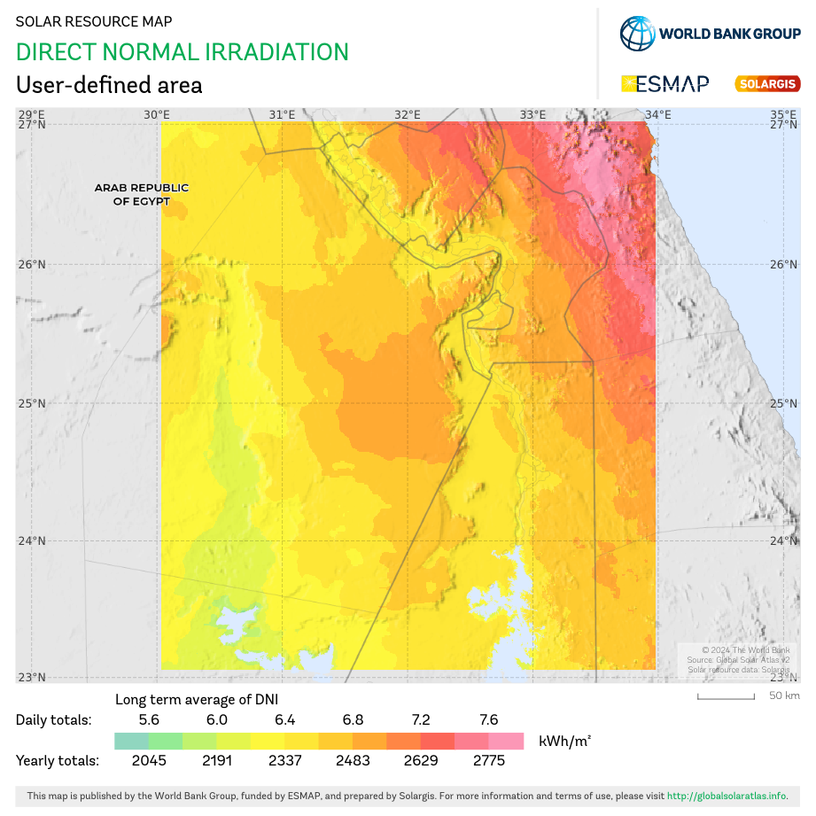
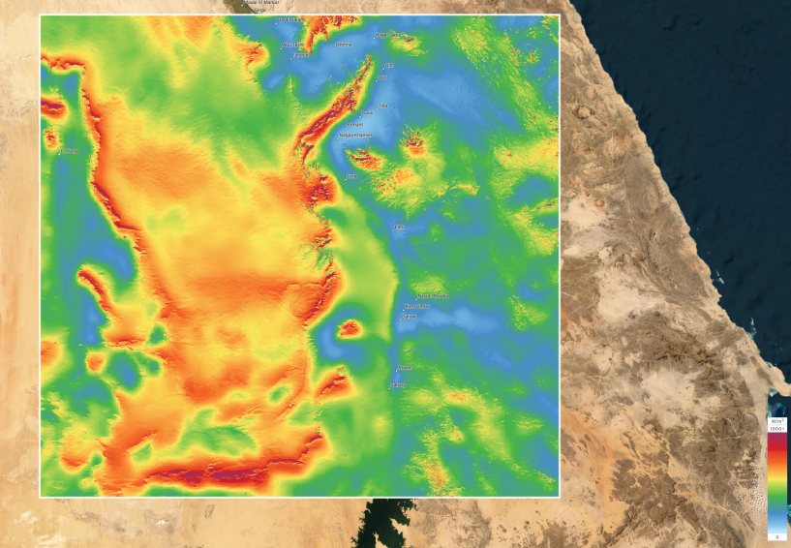
Only about 4% of Egypt’s energy consumption which was is solar energy and wind energy, which is a low percentage compared to the possible solar and wind energy output of Egypt due to the mean power density it receives. For example, the mean wind power density at a height 100 meters south of the western desert in the new valley is 716 W/m² as shown in Figure 5, and the direct normal irradiation it receives, which is equal to 5.95-7.12 kWh/m2 as shown in figure 6. This low percentage comes back to the expensive price of the wind turbines, solar panels, and batteries needed to generate enough solar energy to satisfy Egypt’s electricity consumption, the time needed to construct the wind turbines and solar panels, and the maintenance cost of the solar panels and wind turbines due to the climate of the arid areas in Egypt.
5figure 5 mean wind power density at 100m in the new valley area
6figure 6
2 source: global wind atlas https://globalwindatlas.info/en/

